**MODULE: 6 (Bootstrap Basic & Advance)**

1. **What are the advantages of Bootstrap?**

**Ans.** Bootstrap is an open-source CSS framework designed to come up with mobile-friendly, responsive front-end web development. It consists of enormous versatile and reusable pieces of code written in HTML, JavaScript, and CSS. As a framework, fundamentals are already placed for responsive web development, and developers simply need to position the code in a premeditated grid system. Therefore, while coming up with a new website or application, Bootstrap is a boon because it waives off the burden of coding from scratch. You can efficiently blend its ready-made coding blocks, CSS-Less functionality, and cross-browser compatibility to save tedious hours of coding.

1 **Easy initiation**

**2 Responsiveness**

**3 Highly customizable**

**4 Extremely user-centric**

**5 Top-notch support**

**2.** **What is a Bootstrap Container, and how does it work?**

**Ans. Bootstrap Containers** are the most basic layout element in Bootstrap. Bootstrap **Containers**are very essential and basic building blocks of bootstrap that wrap a page’s content. It’s responsible for setting and aligning content within it according to viewport or given device. Containers are defined within the container class **(.container)**. In other words, we can say that containers are established the width for the layout to give the content. Elements and content are added within the container.

**Containers are used for many purposes such as –**

* It requires use with the default grid system.
* To establish width for the layout to give web content.
* To provide responsive fixed behavior of any web project.
* To sets the content margin dealing with the responsive behavior of your layout.

Basically, there are three types of container classes available in bootstrap:

1. Default-Container(container)
2. Responsive-Container(along with sm, md, lg, xl, xxl)
3. Fluid-Container(container-fluid)

**3 .What are the default Bootstrap text settings?**

**Ans.** Bootstrap 4 Default Settings

Bootstrap 4 uses a **default font-size of 16px, and its line-height is 1.5**. The default font-family is "Helvetica Neue", Helvetica, Arial, sans-serif. In addition, all <p> elements have margin-top: 0 and margin-bottom: 1rem (16px by default).

**4 .What do you know about the Bootstrap Grid System?**

## **Ans. Bootstrap Grid System**

1. [Introduction and Installation](https://www.geeksforgeeks.org/beginning-bootstrap-part-1/)
2. [Buttons, Glyphicons, Tables](https://www.geeksforgeeks.org/bootstrap-part-3/)
3. [Vertical Forms, Horizontal Forms, Inline Forms](https://www.geeksforgeeks.org/bootstrap-part-4/)
4. [DropDowns and Responsive Tabs](https://www.geeksforgeeks.org/bootstrap-part-5/)
5. [Progress Bar and Jumbotron](https://www.geeksforgeeks.org/bootstrap-part-6-progress-bar-jumbotron/)

**5 .What is the difference between Bootstrap 4 and Bootstrap 5**

**Ans.**

**Difference between Bootstrap 4 and Bootstrap 5**

| **BASIS OF** | **BOOTSTRAP 4** | **BOOTSTRAP 5** |
| --- | --- | --- |
| **Grid System** | It has 5 tier (xs, sm, md, lg, xl). | It has 6 tier (xs, sm, md, lg, xl, xxl). |
| **Color** | It has limited colors. | Extra colors added with the looks, A card improved color palette. there are various shades available to choose. |
| **Jquery** | It has jquery and all related plugins. | Jquery is removed and switched to vanilla JS with some working plugins |
| **Internet Explorer** | Bootstrap 4 supports both IE 10 and 11. | Bootstrap 5 doesn’t support IE 10 and 11. |
| **Form elements** | Radio buttons, checkboxes have different look in different OS and browsers. The form uses whatever default browsers provide. | The look of form elements will not change, on different OS or browser. The forms can be customized and form controls can be added, they would not depend on browser. |
| **Utilities API** | We cannot modify utilities in bootstrap 4 | Bootstrap 5 gave freedom to modify and also create our own utility |
| **Gutter** | We use .glutter with fontsize in px | We use .g* with fontsize in rem |

1. **What is a Button Group, and what is the class for a basic Button Group?**

**Ans.**“Button Groups” in Bootstrap is a class of name “btn-group” which is used to create series of buttons in groups (without spaces) vertically or horizontally.

This is the basic syntax of the button group class where each button has its own class of “btn”.

<div class="btn-group">

<button type="button" class="btn">Click</button>

</div>

Buttons have a default border-radius on the first and last buttons of the group.

**Adding Styles on Buttons**

**Sizing of your Buttons**

**Vertical Button Groups**

**Nesting of Buttons**

1. **How can you use Bootstrap to make thumbnails?**

**Ans.**

**Bootstrap**: helps web developers to create thumbnails that are used to show linked images in grids with the pre-defined classes which help to reduce codes length. Thumbnails are created to provide a quick preview of images with small images.

**Thumbnail:**A thumbnail is a small image that represents a larger image. Bootstrap has an easy way to do this with thumbnails.

1. **How can one create an alert in Bootstrap?**

**Ans.**

**Approach:** The .alert class followed by contextual classes are used to display the alert message on website. The alert classes are: .alert-success, .alert-info, .alert-warning, .alert-danger, .alert-primary, .alert-secondary, .alert-light and .alert-dark. We can use .alert-warning to create warning notification alerts in bootstrap.

Below is the procedure to implement a simple warning alert in Bootstrap.

1. **What is a bootstrap card and how would you create one?**

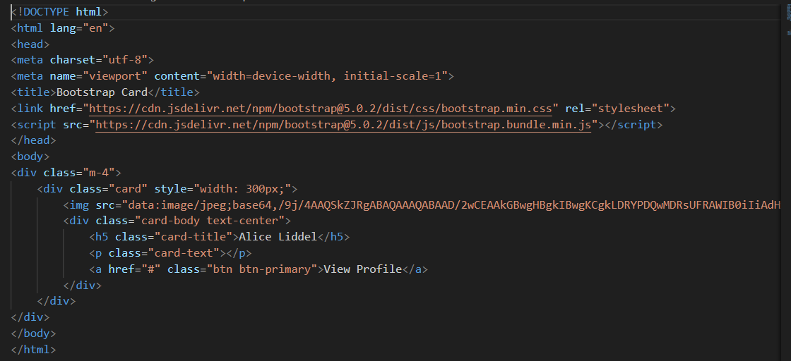

OUTPUT:

